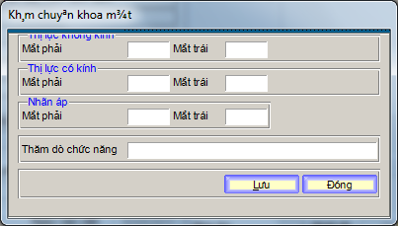

- Lam Dialog nhap nhieu nhu hinh tren

-- Table: hms_advancedexmeye

-- DROP TABLE hms_advancedexmeye;

CREATE TABLE hms_advancedexmeye
(
haee_facid integer NOT NULL,
haee_docno integer NOT NULL,
haee_deptid character varying(7),
haee_receptid integer,
haee_roomid integer,
haee_bedid integer,
haee_idx integer NOT NULL,
haee_entrydte timestamp without time zone,
haee_unglassleft character varying(7),
haee_unglassright character varying(7),
haee_glassleft character varying(7),
haee_glassright character varying(7),
haee_eyeballleft character varying(7),
haee_eyeballright character varying(7),
haee_explorefunc character varying(254),
CONSTRAINT hms_advancedexmeye_pkey PRIMARY KEY (haee_facid, haee_docno, haee_idx)
)
WITHOUT OIDS;
ALTER TABLE hms_advancedexmeye OWNER TO postgres;

